Danh sách chỉnh lý.

- Trang 71/đánh dấu 61-62:
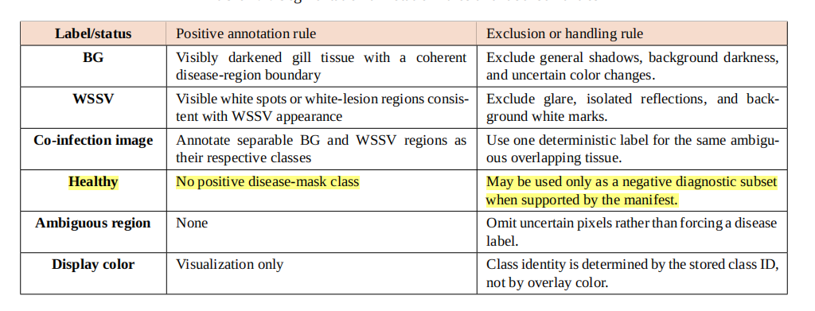
Tiếng Việt: Healthy được sử dụng trực tiếp là data không có mask, không phải data “có thể được sử dụng”
Tiếng Anh: Healthy images are retained in train/validation/test as empty-label negative samples, not merely as an optional diagnostic subset.

Cụ thể chỉnh sửa: Include Healthy images in the train, validation, and test partitions. Use them for negative supervision and Healthy false-positive diagnostics.

- Trang 70-71/đánh dấu 61-62:
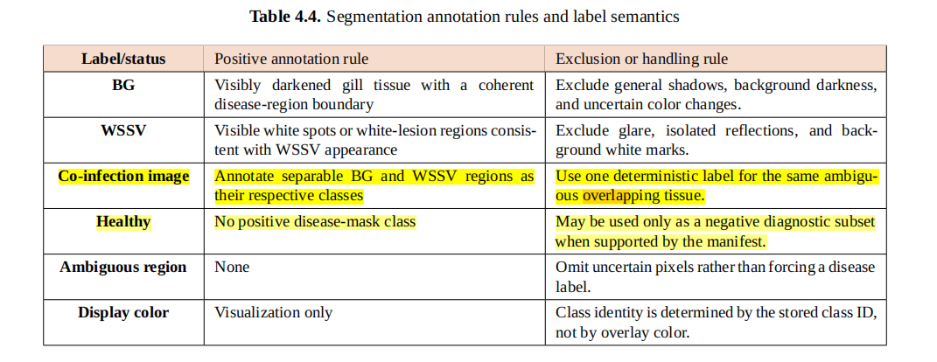
Tiếng Việt: “Khi overlap thì WSSV được ưu tiên sử dụng để label“
Tiếng Anh: “when annotated regions overlap, one deterministic label is retained, with WSSV taking project-specific priority. “
Cụ thể chỉnh sửa: “When annotated disease regions overlap, retain one deterministic target; WSSV takes project-specific priority in the overlapping pixels.”

Sau table thêm đoạn sau:
Ultralytics YOLO segmentation supports multiple instances and multiple classes in the same image. The project therefore retained separable BG and WSSV regions as independent class-specific instances in co-infection images. A multilabel semantic target was not assigned to the same annotated pixel. When the project-authored BG and WSSV regions overlapped, the overlap was resolved through one deterministic annotation rule in which WSSV took project-specific priority. This policy was adopted to keep the stored training targets consistent; it is not a claim that YOLO cannot represent multiple disease instances, nor is it a biological claim that one disease replaces the other.
Healthy images are known negative samples rather than missing annotations. Their label files contain no positive disease polygon because no visible BG or WSSV region is present. In training, no matched positive instance contributes box or mask regression terms for these images, while the detection/classification branch still receives negative supervision against disease predictions. Healthy behavior is therefore reported separately through the Healthy false-positive rate and the number of false masks per Healthy image.

- Trang 73/đánh dấu 63:
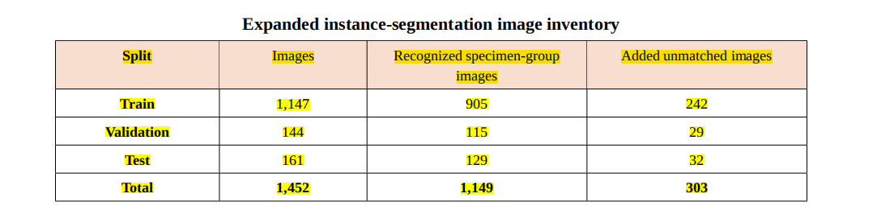
Tiếng Việt: “Đối với tập expanded chứa tập gốc + tập bổ sung thứ 2 và 3, chỉ có tập đầu được chia theo specimen, phần còn lại chia theo strat random split”
Tiếng Anh: “1,149 convention-matched images use grouped-specimen allocation, while 303 unmatched-name images use image-level stratified random allocation; the merged 1,147/144/161 split is therefore not fully specimen-leakage-free.”
Giải thích data gốc:
The primary instance-segmentation dataset contained 1,149 images associated with 416 filename-derived specimen groups. It included 746 images with at least one project-authored BG or WSSV mask and 403 Healthy images retained as empty-label negatives. Across the dataset, 1,031 mask instances were recorded: 462 BG instances and 569 WSSV instances. A total of 220 images represented the WSSV_BG co-infection image category; these images retained BG and WSSV as the two mask classes rather than introducing a third co-infection mask class.
The primary dataset was divided using disease-stratified grouped-specimen allocation. All views sharing the specimen key `Disease::ShrimpID` were assigned to the same partition. The resulting split contained 905/115/129 train/validation/test images and 331/40/45 specimen groups. No specimen key was shared between train and validation, train and test, or validation and test.
Giải thích data expanded:
The expanded dataset was evaluated only as an additional dataset-composition transfer assessment. It combined the 1,149 convention-matched images with 303 added images whose filenames did not provide compatible specimen identifiers. The convention-matched subset retained grouped-specimen allocation, whereas the 303 unmatched-name images were allocated by image-level stratified random splitting before the partitions were merged. The final expanded split contained 1,147 training images, 144 validation images, and 161 test images. Because specimen identity was unavailable for the unmatched subset, the complete expanded split cannot be described as fully specimen-leakage-free. The accurate scope is that group leakage was prevented for convention-matched images, while unmatched images were stratified at image level.

- Trang 73/đánh dấu 63:
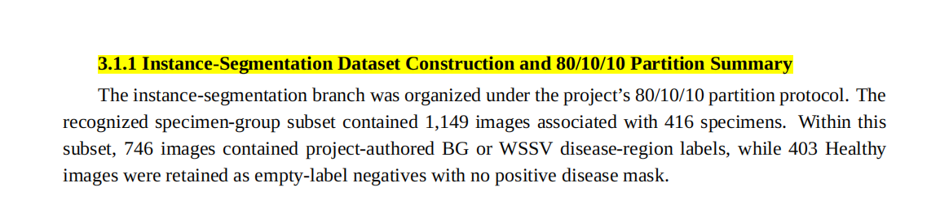
Section sai, trên là 3.2, dưới là 3.3, ở giữa nên dùng section khác

- Trang 74/đánh dấu 64:
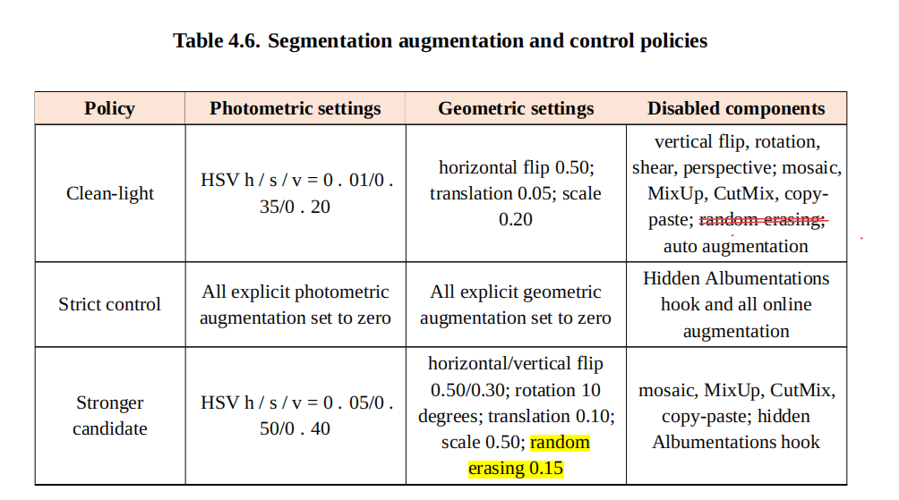
Tiếng Việt: “random erasing có thể bỏ ra, vì bên phía segmentation YOLO sẽ bỏ qua phương pháp aug này (không tồn tại đối với pipeline segmentation)”
Tiếng Anh: “random erasing is not an active component of the strong segmentation policy. `erasing=0.15` was present in recorded arguments but was ignored by Ultralytics 8.4.62 `v8_transforms`;

- Thay đổi hình ảnh để thể hiện rõ thay đổi về phổ và điểm khác biệt trong cả miền không gian lẫn tần số:
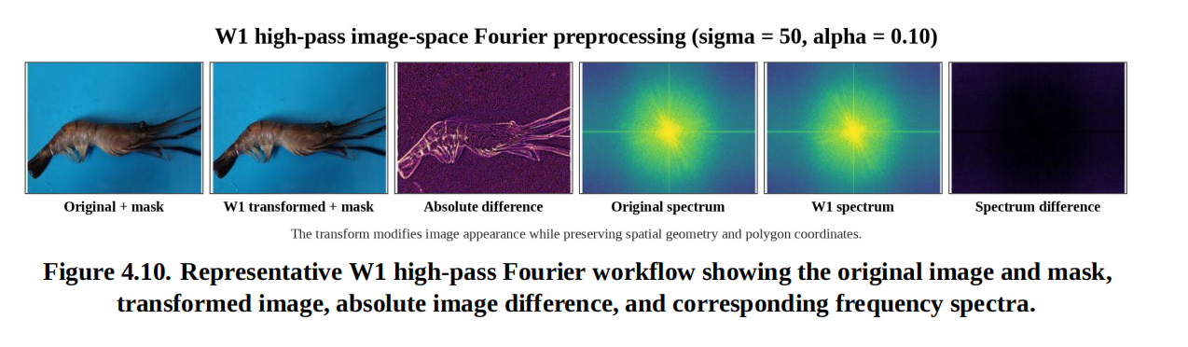
new: 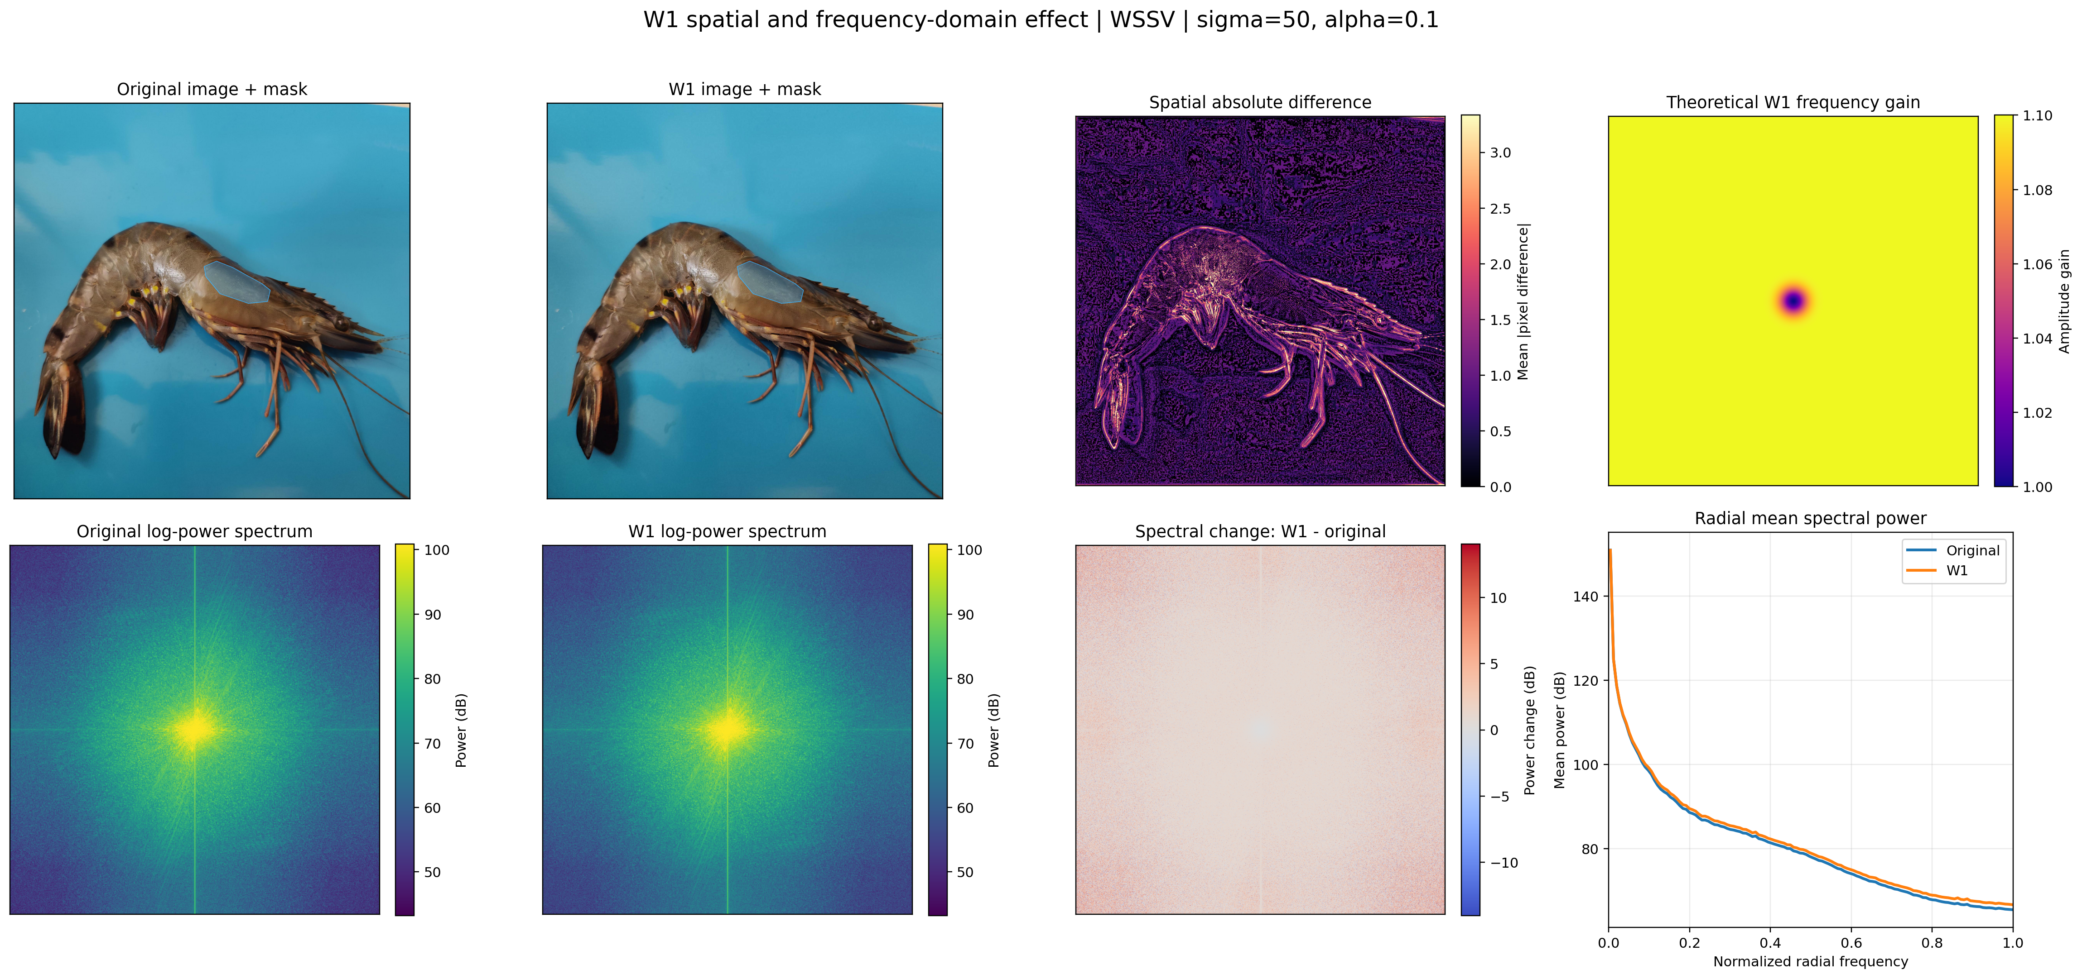
Figure 4.10. Representative spatial- and frequency-domain effect of W1 (`sigma=50`, `alpha=0.10`). The panels compare the original and transformed image, the spatial absolute difference, the theoretical frequency gain, the original and W1 log-power spectra on a shared scale, the signed spectral change, and the radial mean power profile. The original image remains recognizable because W1 retains the full image and adds only a scaled high-frequency residual.
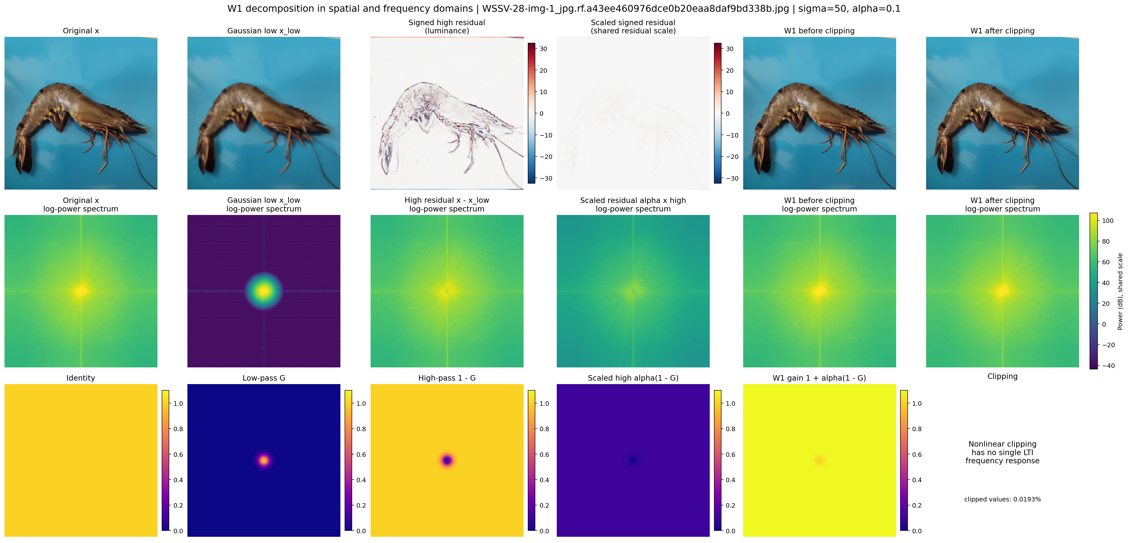
Figure D.x. Exact W1 decomposition in the spatial and frequency domains. The figure shows the original image, Gaussian low-frequency reconstruction, signed high-frequency residual, scaled residual, W1 result before clipping, and W1 result after clipping and `uint8` quantization, together with their spectra and theoretical filter responses. The reconstruction audit verified `x = x_low + x_high` up to floating-point precision. Clipping and quantization are nonlinear and therefore do not have one linear shift-invariant frequency response.

- Trang 119/đánh dấu 110:
Giải thích train-test overlap là gì:
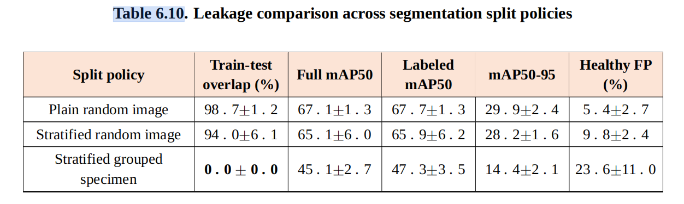
Tiếng Việt: “Train test overlap là phần trăm số lượng group có trong tập test cũng có trong tập train, này là dựa theo group chứ không phải dựa theo hình ành”
Tiếng Anh: “For a given split, train-test overlap was defined as `100 x |G_train intersect G_test| / |G_test|`, where `G_train` and `G_test` are the sets of filename-derived specimen keys in the training and test partitions. The measure is therefore the percentage of test specimen groups that also appear in training. It is not the percentage of image files that overlap and not the fraction of views from an individual specimen that leaked. Table 6.10 reports the mean and standard deviation of this group-level quantity across the three recorded seeds (42, 123, and 3407).”

- Thay đổi phần giải thích tại sao chọn yolo11n-seg:
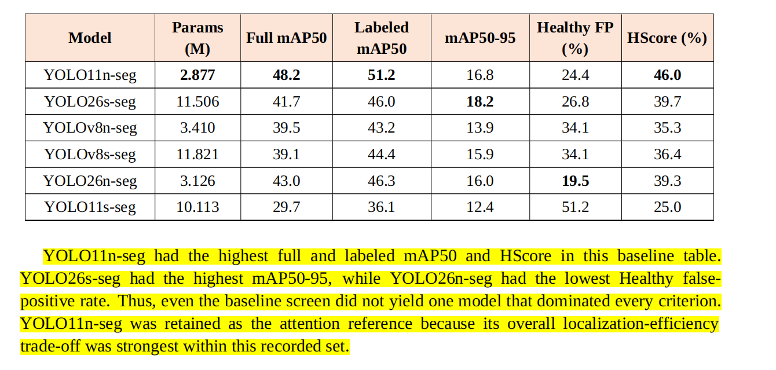
Đổi phần bôi vàng thành:
YOLO11n-seg was retained as the reference architecture because it provided the strongest overall localization-efficiency trade-off in the recorded grouped-specimen comparison, rather than because it dominated every metric. With 2.877 million parameters, it achieved the highest full-test mask mAP50 (48.2%), labeled-only mask mAP50 (51.2%), and HScore (46.0%) in the six-model panel. YOLO26s-seg achieved the highest labeled mAP50-95 (18.2%) but used 11.506 million parameters and produced lower main mAP50 and HScore. YOLO26n-seg achieved the lowest Healthy false-positive rate (19.5%) but lower full-test and labeled-only mAP50. YOLO11n-seg was therefore selected as the compact balanced baseline for subsequent attention, preprocessing, and augmentation experiments; the result is specific to the recorded grouped-split protocol and is not a universal architecture ranking.

- Trang 80/đánh dấu 71:
Gốc:
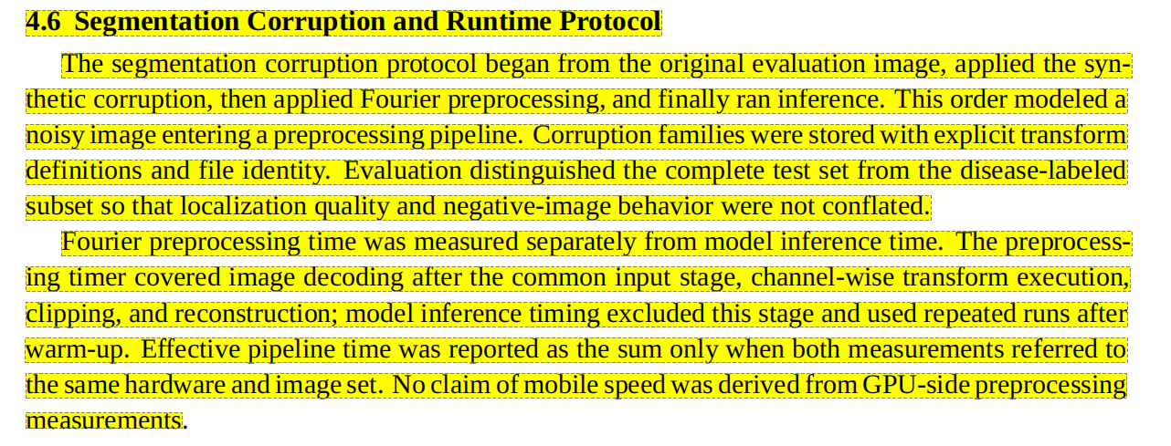
Chỉnh sửa:
Mở rộng với:
””To examine the interaction between W1 and the recorded strong augmentation policy, a paired image-spectrum study was conducted on 24 held-out test images sampled with seed 42. The sample contained six Healthy, six BG, six WSSV, and six WSSV_BG images. Each image was processed under 12 matched augmentation realizations and five image paths: original, W1 only, strong augmentation only, W1 followed by strong augmentation, and strong augmentation followed by W1. The same sampled augmentation parameters were reused across the matched paths for each image-realization pair.

The active strong-policy replica followed the Ultralytics 8.4.62 segmentation transform order and equations for letterbox resizing, random rotation, translation, scale, HSV transformation, vertical flip, and horizontal flip. Mosaic, MixUp, CutMix, copy-paste, shear, perspective, and the hidden Albumentations hook were disabled.

The analysis produced 288 paired observations for each global image metric and 216 observations for lesion-region metrics because Healthy images contain no lesion mask. Recorded measurements included normalized low-, mid-, and high-band spectral-energy share, radial power, mean gradient magnitude, Laplacian variance, lesion-region gradient, background gradient, and clipping fraction. This experiment measured image-distribution and spectrum changes. It did not retrain the complete model under both strong-policy processing orders and therefore cannot by itself establish a causal relationship between spectral changes and segmentation mAP.””

- Trang 124/đánh dấu 115:
Thêm vào sau hình ảnh:
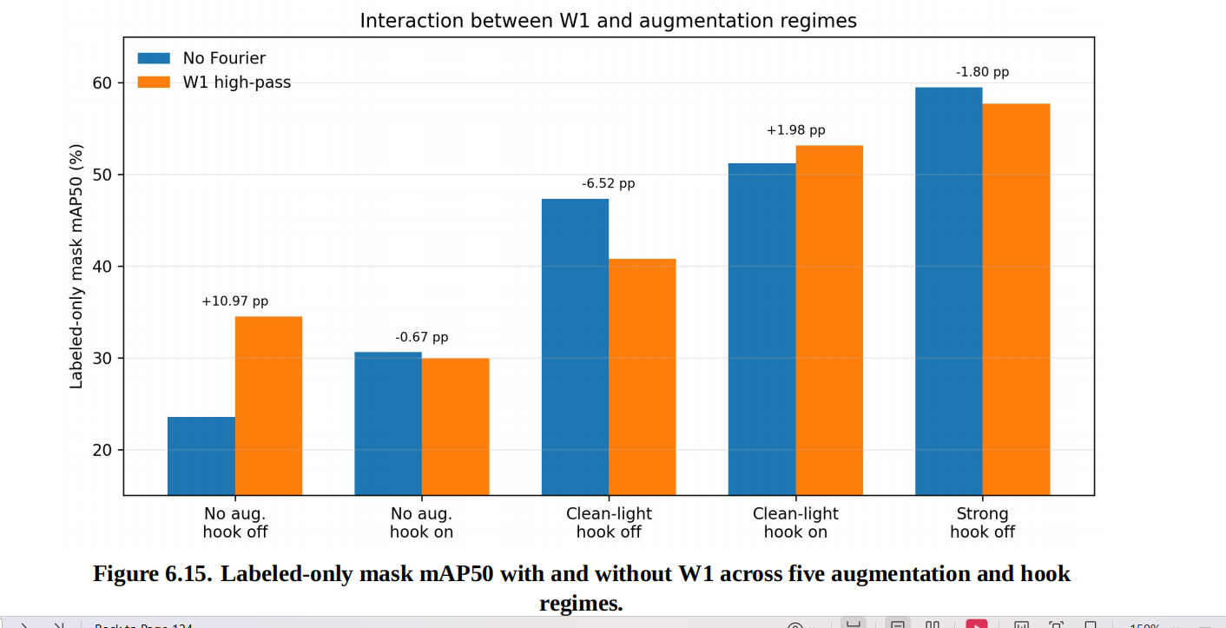

Nội dung
Table 6.x. Paired incremental effect of W1 before and after matched strong augmentation

| Metric | W1 effect without augmentation | Incremental W1 effect after matched strong augmentation | Retained W1 effect |
|---|---:|---:|---:|
| Low-band energy share | -0.001158 | -0.000434 | 37.5% |
| Mid-band energy share | +0.000488 | +0.000283 | 58.0% |
| High-band energy share | +0.000670 | +0.000151 | 22.5% |
| Mean gradient | +0.010979 | +0.006157 | 56.1% |
| Laplacian variance | +0.003127 | +0.000660 | 21.1% |
| Lesion-region gradient | +0.012104 | +0.009561 | 79.0%
Note: Values are paired mean changes produced by adding W1 to the corresponding base path; they are not absolute spectral-energy shares. “Retained W1 effect” is the ratio between the incremental W1 effect after augmentation and the W1-only effect. The lesion-region metric excludes Healthy images.
Thêm giải thích:
”””The paired spectrum analysis showed that strong augmentation did not completely remove the W1 effect, but substantially reduced or redistributed its incremental global high-frequency emphasis. Without augmentation, W1 increased the high-band energy share by 0.000670 on average. After the same images had undergone matched strong augmentation, the additional increase caused by W1 was 0.000151, corresponding to 22.5% of the original W1 effect. The retained effects were 21.1% for Laplacian variance and 56.1% for mean gradient. The lesion-region gradient retained approximately 79.0%, indicating that W1 continued to enhance some local disease-region boundaries even though most of its global spectral contribution overlapped with the augmented image distribution.

The active strong policy introduced HSV variation, horizontal and vertical flipping, rotation, translation, and scale. Affine interpolation can attenuate fine detail, while rotation, translation, padding, and image boundaries introduce structured frequency components. HSV also changes intensity relationships between channels. In the recorded Path 15 training pipeline, W1 was applied offline before online strong augmentation; W1-enhanced edges were therefore subsequently resampled and color-transformed. The strong-augmentation-only model already learned from a broader distribution, so adding a fixed high-pass bias could become redundant or overemphasize texture and noise that were not useful for localization.

This mechanism is consistent with the observed seed-42 model interaction: labeled mask mAP50 changed from 0.2354 to 0.3451 under strict no augmentation, but from 0.5951 to 0.5771 under strong augmentation. The spectrum analysis supports an overlap or redistribution explanation, but it does not prove that the measured spectral change caused the mAP reduction. Multi-seed matched training would be required before describing the negative interaction as statistically confirmed.”””
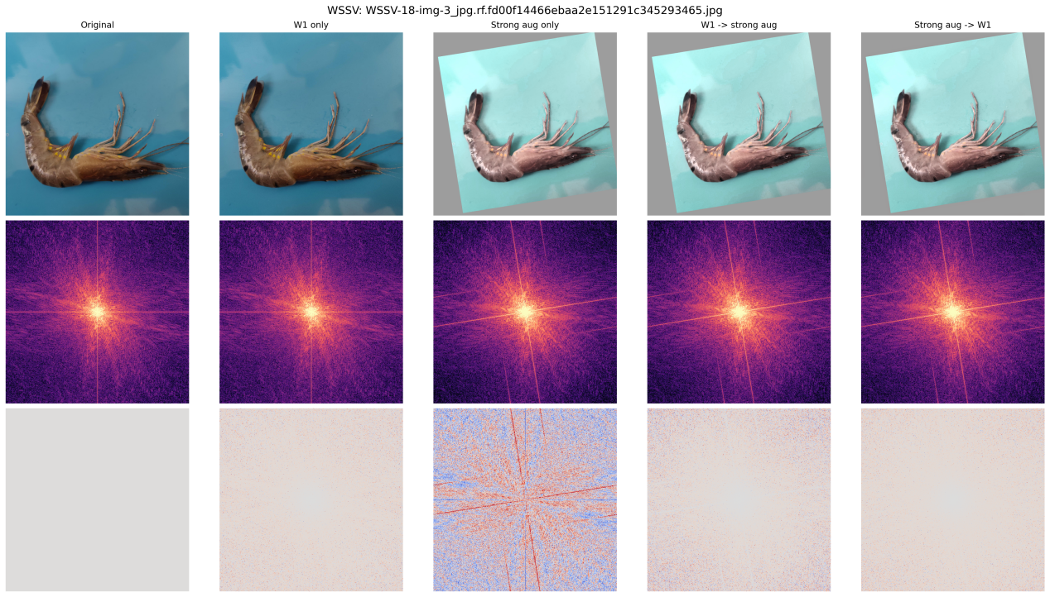
Figure 6.x(a). Representative matched WSSV image under five processing paths. The rows show the spatial image, log-power spectrum, and signed spectral change relative to the original path. Strong augmentation introduces larger geometric and color changes than W1 alone, while the difference between the two combined orders is visually smaller. This image is illustrative; the quantitative findings use all 24 images and 12 realizations.

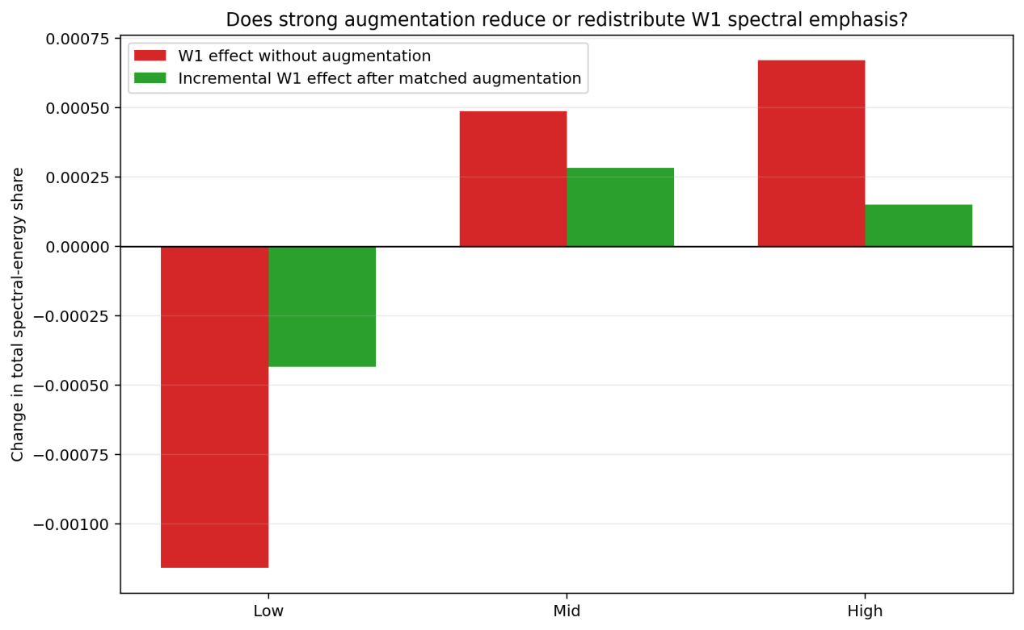
Figure 6.x(b). Incremental W1 spectral-energy effect before and after matched strong augmentation. Red bars show the mean change produced by W1 without augmentation, and green bars show the additional W1 change after the corresponding strongly augmented image. Strong augmentation retained only 22.5% of W1's original high-band energy-share effect.

